LINUX PROGRAMMING ASSIGNMENT 10

NAME: DISHA S
USN: ENG24CY0018
CLASS: 3C
ROLL.NO: 35

BASIC COMMAND:

du – Show disk usage of files/directories

1. what is the said command little history, invention, authors of the command?

The du command stands for " disk usage ", and it is a utility that can be found on all Unix-like systems, be those Linux, MacOS, BSD, etc. It is usually used to estimate and display the disk space used by files and directories within a given path, enabling users to understand how much storage each of these items occupies. du remains vital to storage management, system administration, and scripting as modern systems have evolved and storage technologies changed.​

History :

The du command originated in Version 1 of AT&T UNIX in the early 1970s at a time when modern operating systems were just being developed at Bell Labs.​ It was designed with the philosophy of writing programs that were small and performed a single function to make it easy for users to measure storage use on fast but limited disk systems at that time.​

Invention :

It was invented by the original Unix team, Ken Thompson and Dennis Ritchie, along with other Bell Labs engineers who strove to make each utility simple and dedicated to one purpose. The command du was invented with the other simple, modular commands—like ls and df—that empowered users with the ability to investigate their systems with speed and clarity. The command follows the Unix philosophy of "do one thing well" and thus provides a simple interface for measuring storage use without complex configuration.

Authors:

AT&T Bell Labs: The utility was written originally by Bell Labs engineers in the early 1970s, including members of the original Unix development team at that time: Ken Thompson, Dennis Ritchie, and others.

GNU Coreutils Implementation:

- Torbjorn Granlund: Author of early GNU versions, implemented several utilities for GNU coreutils.​
- David MacKenzie: Made significant contributions to codebase consistency and portability.​
- Paul Eggert: Maintained heavily, adapted to standards, expanded functionality.​
- Jim Meyering: Key developer and maintainer of GNU coreutils.​
- Mark Russinovich: Wrote Sysinternals Windows version.

(2) Why the particular command useful for System administrator?

System administrators monitor disk space constantly to avoid downtime and to hunt down storage bottlenecks. Here are some important uses of du:

- Finding out which directories or files are using the most space.

- Diagnose when a disk or partition is filling up.

- Auditing user disk consumption.

- Preparation for backup includes determining what needs archiving or cleaning up.

(3) How these said commands are working? Give proper example.

How du works is straightforward: It takes either a directory or a specific file, and it reports on its space usage. By default, it recurses through directories, adding up the space for each subdirectory.

Example 1: Basic Usage
Command : du /var
What it does: Displays disk usage for /var and all of its subdirectories.

Example 2: Human-Readable and Summary
Command : du -sh /home
What it does:
-s: Only top-level total.
-h: Prints in the more understandable units, KB, MB and GB.

Example 3 : See one Level of Subdirectories
Command : du -h --max-depth=1 /var/log
What it does: Displays the total usage for /var/log and each direct subdirectory, while concealing deeper levels.

Example 4: All Files, Not Just Directories
Command: du -ah /etc | sort -hr | head -10
What it does:
-a: includes all files.
sort -hr | head -10: see biggest ones at the top.

Example 5: Exclude Certain Patterns
Command: du -h --exclude="*.bak" /data
What it does: Ignores backup files ending in .bak.

Example 6: Display Modification Time
Command: du -h --time /home/user
What it does: It shows disk usage with the date files/directories were last modified.

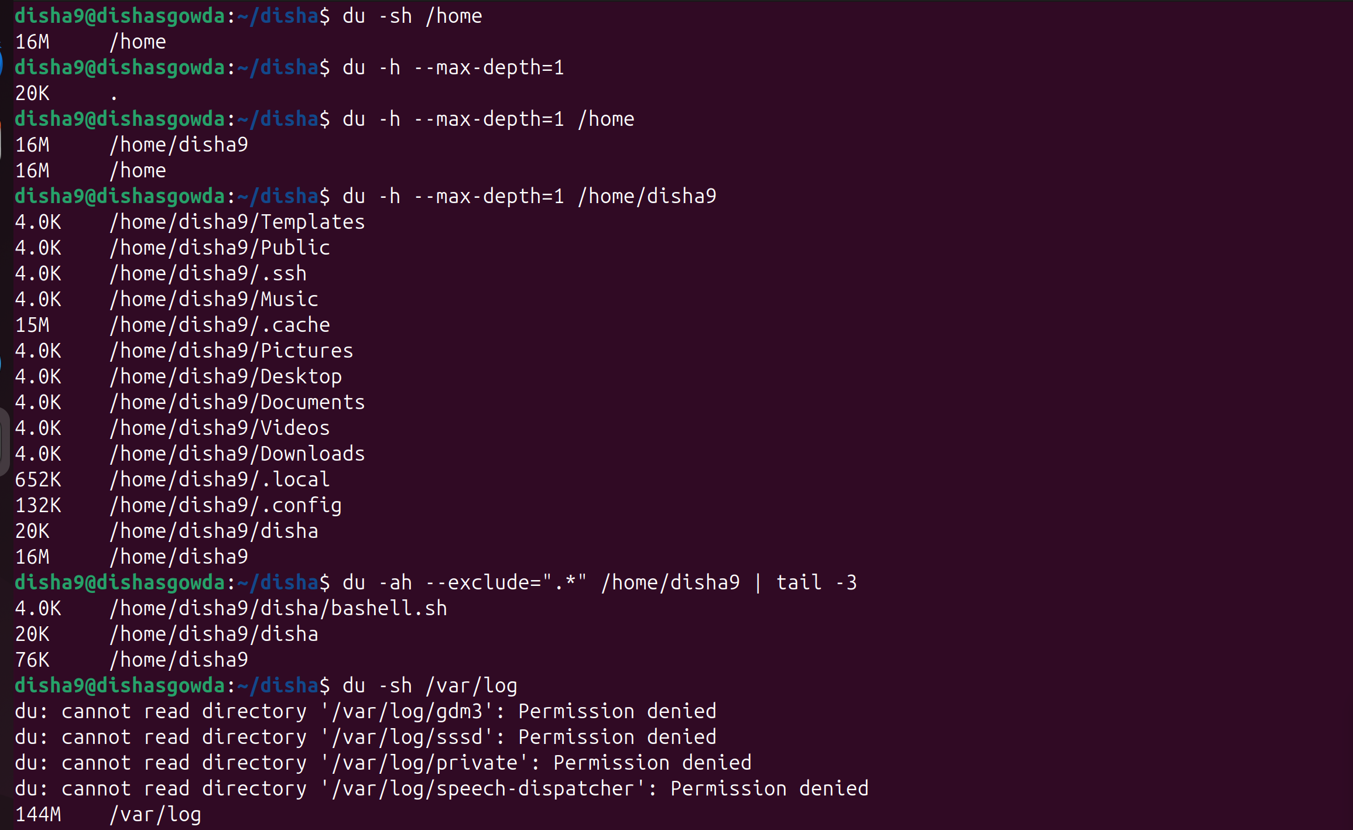
(4) Few snapshot of the command execution with proper illustration.

(5) Elaborate at least five to six Option and Flags related to said command, giving sources for detailed flags and options.

-h : Human-readable output (KB, MB, GB).
Example: du -h /tmp

-s : Summarize—show only a total for each argument (not every subfolder)
Example: du -sh /opt

-a : Show size for all files, not just directories.
Example: du -a ~

--max-depth=N or -d N : limits the output to N levels deep in directories.
Example: du -h --max-depth=2 /srv

—exclude=PATTERN : Exclude files matching pattern.
Example:du -h --exclude="*.bak" /data

-c : Adds a grand total at the bottom.
Example: du -hc /home/user

--time : Displays the time of last modification of each file/directory in output.
Example: du -h --time /home

—inodes : Display inode counts instead of disk usage.
Example:du --inodes /var/tmp

Sources for detailed flags and options:
1. https://www.geeksforgeeks.org/linux-unix/du-command-linux-examples/
2. https://www.linuxteck.com/9-basic-du-command-in-linux-with-examples/
3. https://www.howtoforge.com/linux-du-command/
4. https://www.redhat.com/en/blog/du-command-options

ADVANCED COMMAND:

dmsetup – Device mapper setup

1. What's the said command (little history, invention, authors of the command)?

dmsetup is a command-line utility for managing the Linux kernel's device mapper—a framework that allows you to create and control virtual block devices. These virtual devices map onto real disks in flexible ways—used heavily in logical volume management (LVM), disk encryption (LUKS), snapshots, RAID, and more.​

History & Invention:

Device mapper appeared in the early 2000s within the Linux kernel, allowing system developers and admins to manage complex storage setups that couldn't be done with plain disk partitions. Tools like dmsetup were invented so admins could interact directly with these mappings. The underlying kernel framework came out of the work of kernel developers, at Red Hat, Sistina Software (LVM2), and the broader community.

Authors:

Kernel support for the device mapper resides in Linux itself and is maintained by the open source community.

The dmsetup utility is maintained in the LVM2 code base and its contributors, with major contributions from the Red Hat storage team and others acknowledged in Linux man pages.

(2) Why is the particular command useful to a System administrator?

dmsetup allows the system administrator to:

- Control flexible storage: Logical devices are easily created, inspected, and managed on top of physical disks. This is crucial for LVM, encryption, and combined configurations.

- Diagnose and troubleshoot: Check device mapping tables, statuses, errors, and dependencies directly for advanced troubleshooting.

- Execute advanced operations such as suspending/resuming I/O, renaming logical devices, reloading mappings, and even injecting errors for the purpose of testing.

- Script Automation: Utilized in scripts for server provisioning, automatic failover, migration, and snapshot creation.

3. Explain how the said command works, with a proper example.

dmsetup communicates with the kernel device-mapper. For each of the logical devices, there is a table that describes how its sectors map to physical storage and which features (such as mirroring, encryption, or error injection) are enabled.

Example 1: Listing all device-mapper devices
Command: sudo dmsetup ls
What it does: This lists all mapped block devices, like LVM volumes, encrypted partitions, and snapshots.

Example 2: Provide the mapping table for your logical device:

Command: sudo dmsetup table VG00-data
What it does: This will show how the logical sectors map to physical storage.

Example 3: Display detailed information of the device:
Command: sudo dmsetup info VG00-data
What does it do? It makes a test device named “testdev” mapping the first 1000 sectors of /dev/loop0.

Example 4: Remove a device
Command: sudo dmsetup remove testdev

Example 5: Check status
Command: sudo dmsetup status VG00-data
What does it: It shows current state, health or errors.

(4) Few snapshots of the command execution with proper illustration.
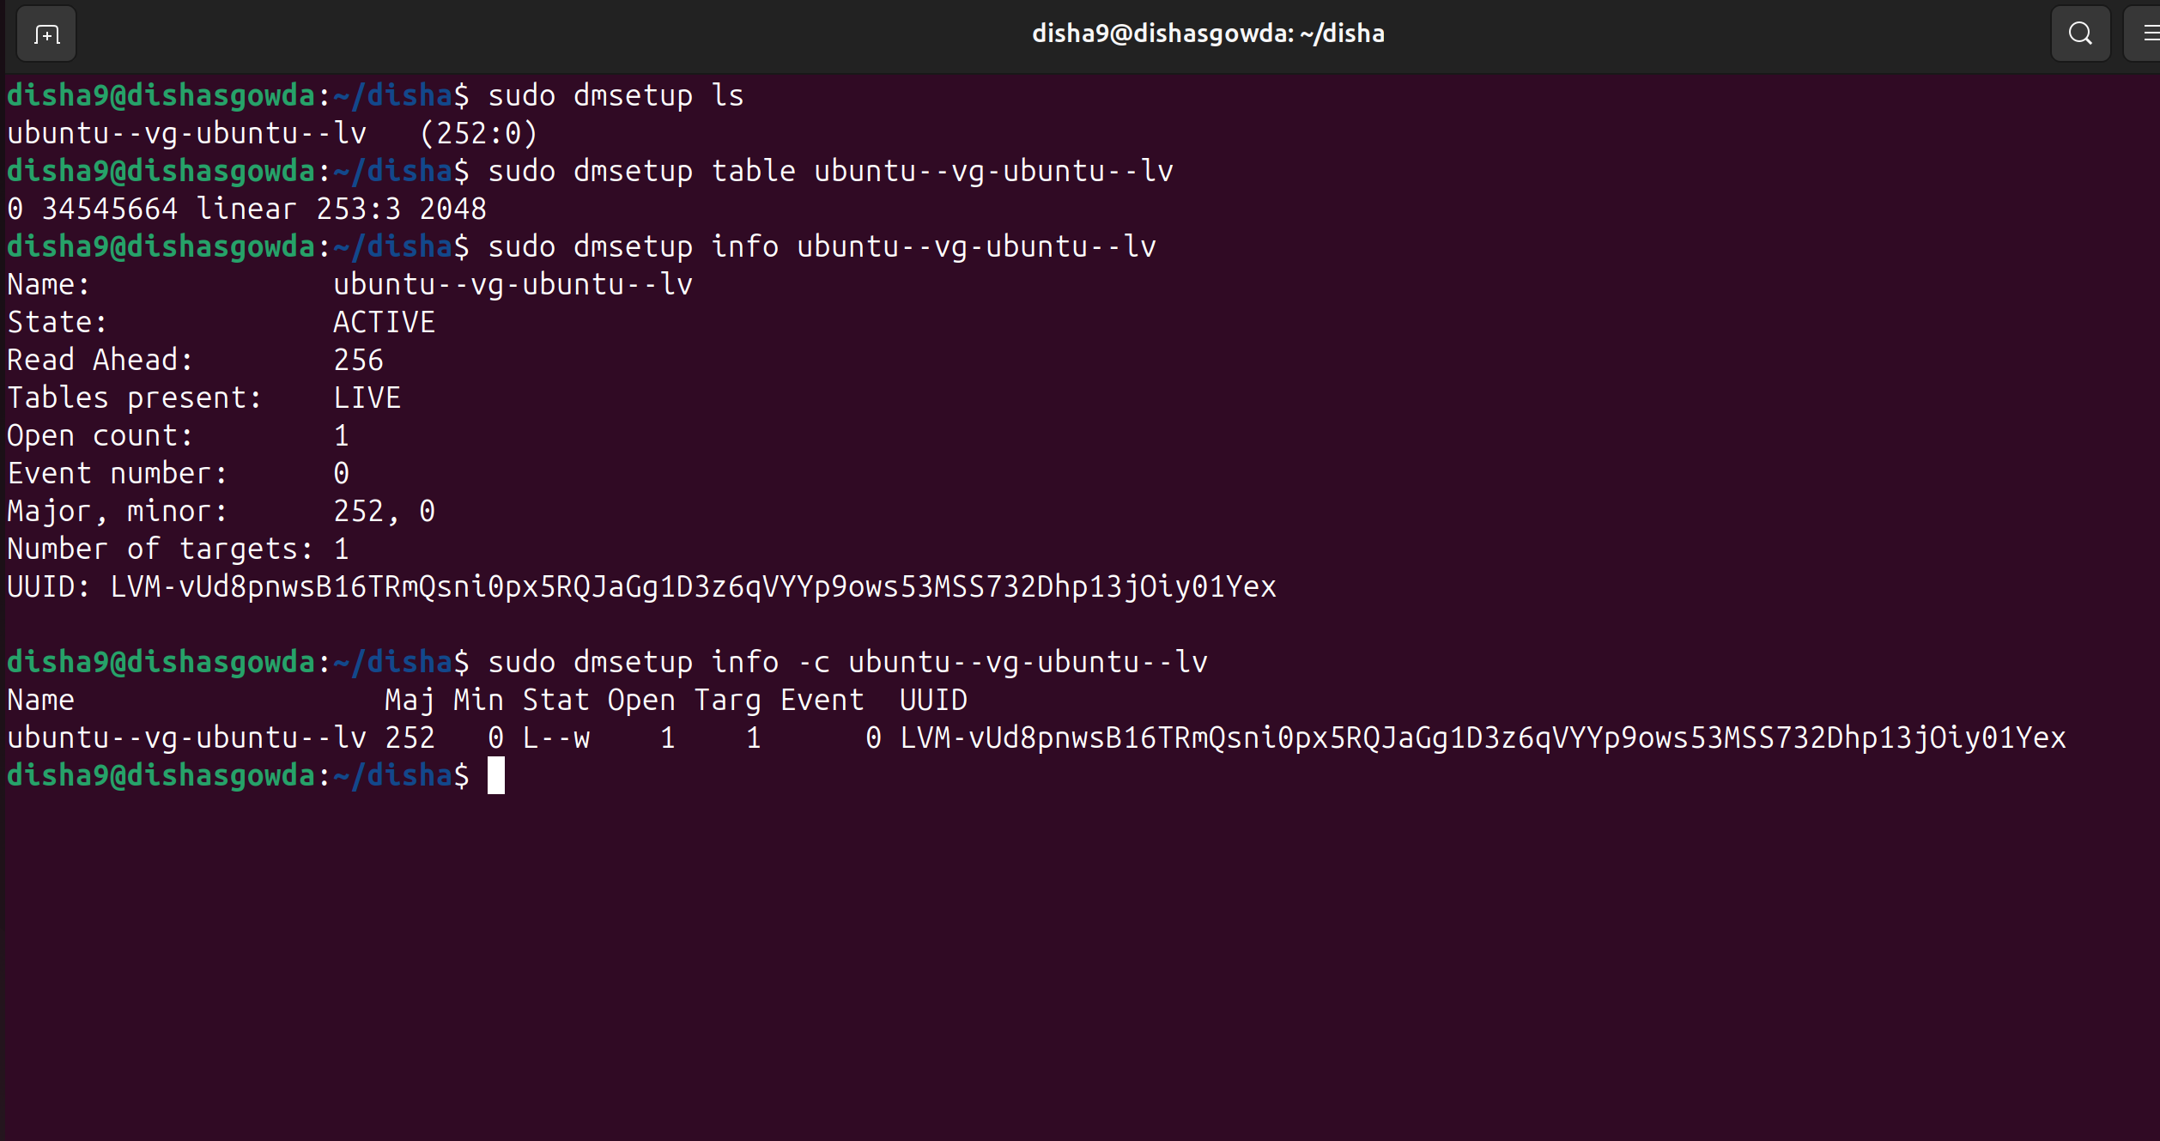

(5) At least elaborate five to six Option and Flags related to the said command. Give sources for detailed flags and options.

ls [--tree]: List devices, display as tree for dependencies.
Example: dmsetup ls —tree

info [-c]: Display information about device(s) in CSV mode with -c.
Example:dmsetup info -c vg0-root

table: Show mapping table for a device.
Example: dmsetup table vg0-root

create: Create a new mapping from a table.
Example: dmsetup create testdev

remove: Remove one or more device-mapper devices.
Example: dmsetup remove testdev

reload: Reload mapping table for a device (in-place replacement)
Example: dmsetup reload vg0-root --table suspend/

resume: Pause (block) or restart I/O for maintenance.
Example: dmsetup suspend vg0-root

status - Query current device status (health, stats)
Example: dmsetup status vg0-root

Sources for detailed flags and options:
- https://man7.org/linux/man-pages/man8/dmsetup.8.html
- https://www.tutorialspoint.com/unix_commands/dmsetup.htm

